

**CHANDIGARH UNIVERSITY**

**DEPARTMENT: UIC**

Bachelors of Computer Application

Subject Name: Computer Programming

24CAH-101

PROJECT

Project name: **SIMPLE CALCULATOR**

Submitted by: **Group (A++)**

Members name:

* **Antra (24BCD10085)**
* **Harmanpreet Kaur (24BCD10073)**
* **Shawyam Gautam (24BCD10086)**

Submitted to: Mrs. Shuchi Sharma

Project Description:

The Simple Calculator project in C is a basic application that performs arithmetic operations such as addition, subtraction, multiplication, and division. It provides a user-friendly interface for entering operands and operators and displays the result of the operation. This project is suitable for beginners learning C programming and can be extended to include more advanced features like scientific calculations.

Features of the project:

* User-friendly interface for input and output.
* Supports basic arithmetic operations.
* Handles error cases like division by zero.
* Ability to perform continuous calculations until the user decides to exit.

**OPERATORS**

Operators in C are symbols that perform specific mathematical or logical computations on values. They are fundamental to any programming language and are used to manipulate data and variables. In C, operators can be classified into several types:

**Arithmetic Operators**

These operators perform basic arithmetic operations such as addition, subtraction, multiplication, division, and modulo. They can be unary (operating on a single operand) or binary (operating on two operands).

The **algorithm** for creating a simple calculator in C is written below:

1. **Start** the program.
2. **Display menu** of operations:
   * Addition
   * Subtraction
   * Multiplication
   * Division
3. **Get user input** for:

* Operation choice
* Two numbers (num1 and num2).

1. **Perform operation** based on choice:

* If choice is **1**: Calculate and display num1 + num2.
* If choice is **2**: Calculate and display num1 - num2.
* If choice is **3**: Calculate and display num1 * num2.
* If choice is **4**: Check if num2 is 0. If so, display an error for division by zero. Otherwise, calculate and display num1 / num2.

1. If an **invalid choice** is entered, display an error message.
2. **End** the program.

Code of the program

#include <stdio.h>

int main()

{

int a, b;

float c;

char name;

printf("Enter the Operator from the following \n+\n-\n*\n/\n");

printf("Choice: ");

scanf("%c", &name);

printf("Enter the First Value :");

scanf("%d", &a);

printf("Enter the Second Value :");

scanf("%d", &b);

switch (name)

{

case '+':

printf("RESULT OF ADDITION =%d", a + b);

break;

case '-':

printf("RESULT OF SUBTRACTION:%d", a - b);

break;

case '*':

printf("RESULT OF MULTIPLICATION:%d", a * b);

break;

case '/':

c=a/b;

printf("RESULT OF DIVISION:%.2f", c);

break;

default:

printf("NOT VALID");

}

return 0;

}

ADDITION USING CALCULATOR:

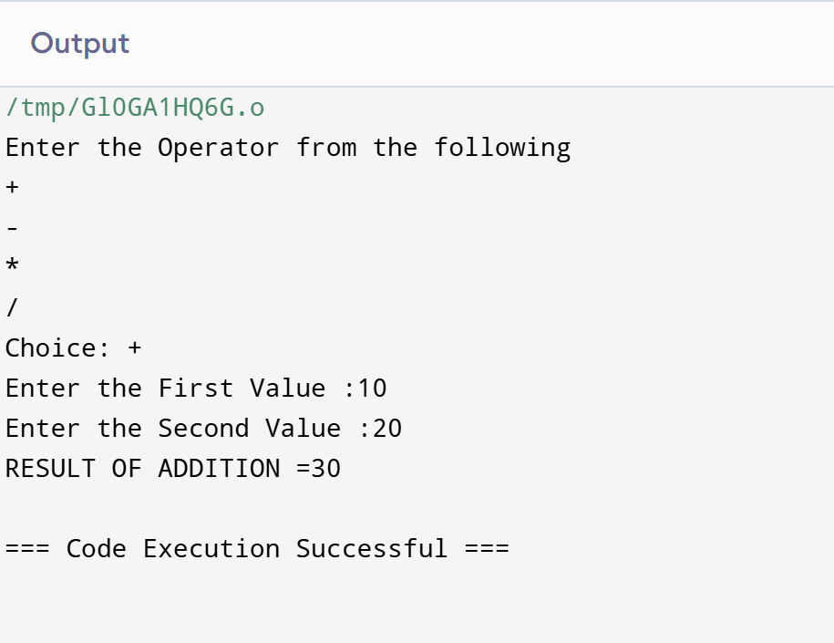

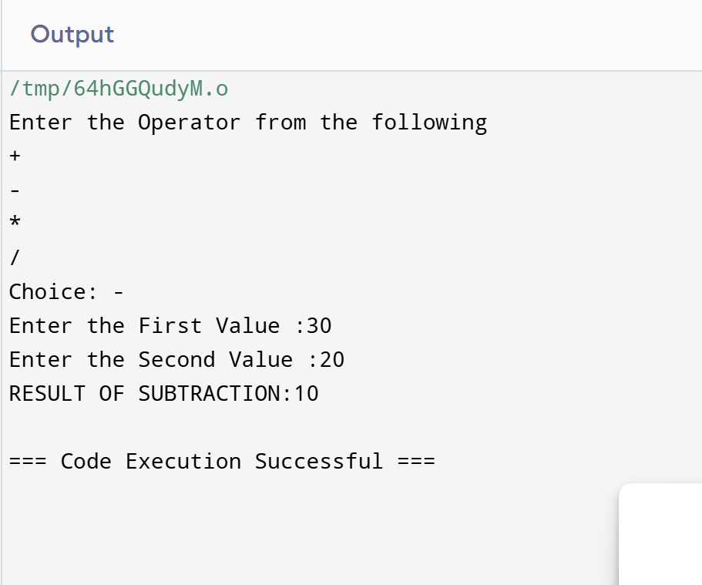SUBTRACTION USING CALCULATOR

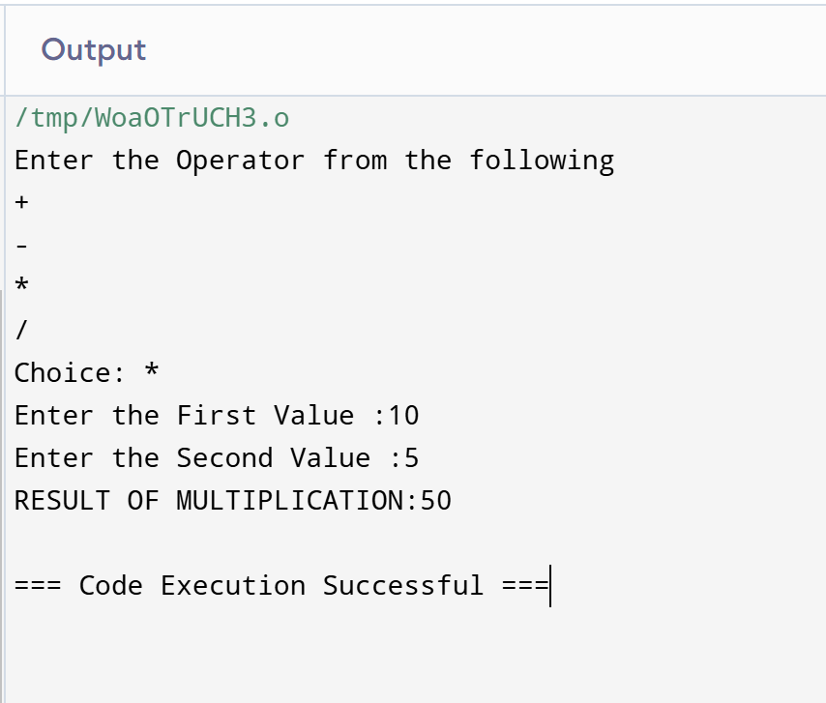MULTIPLICATION USING CALCULATOR

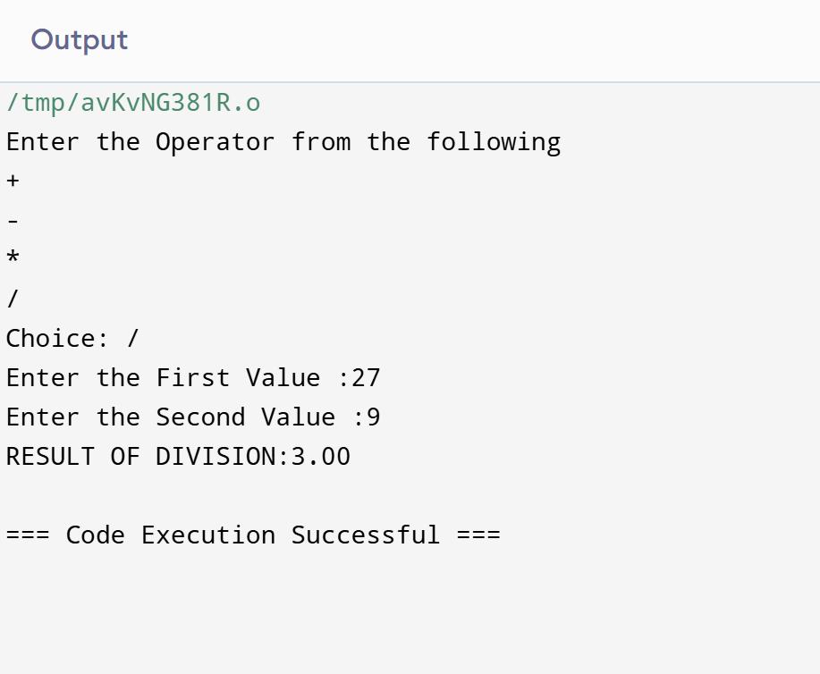DIVISON USING CALCULATOR

FOR INVALID INPUT

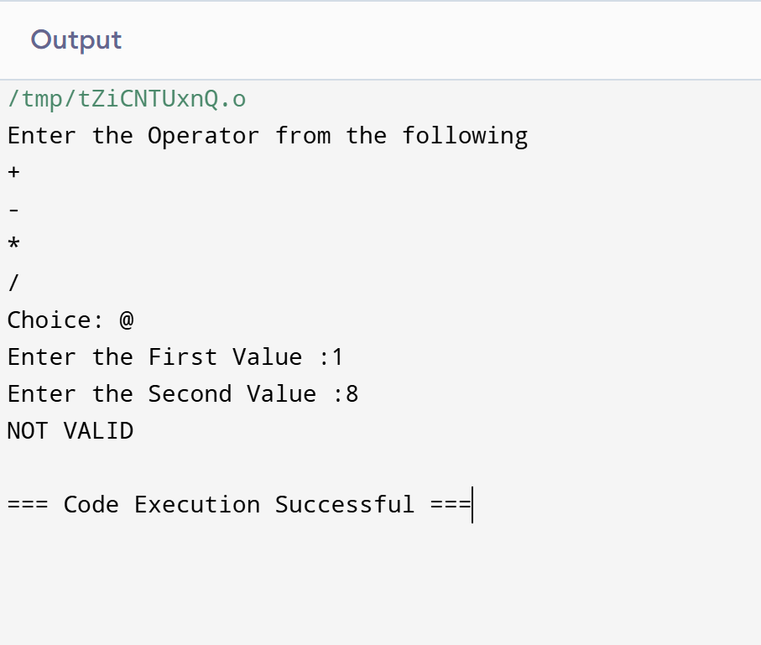

**Summary and Conclusion**

* **Summary**: A simple calculator in C that handles basic arithmetic.
* **Learning Outcome**: Understanding functions, conditionals, and basic error handling in C.
* **Conclusion**: This project provides a foundational understanding of how to build a console-based application in C.